1. On the the lab machine, create the folder:

C:\Server 2008 R2 Labs\Solving Concurrency Issues

1. Copy all the folders from the src file to the directory above.
2. Open Visual Studio, select General Dev Settings
3. Select Tools 🡪 Otions
4. Make the changes detailed below:

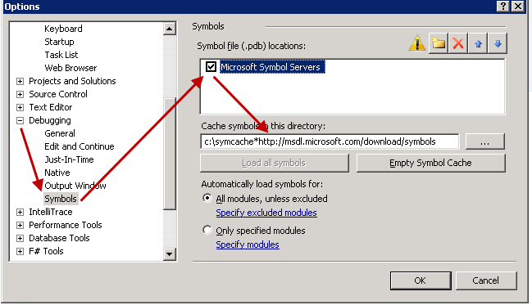

**Note**: The cache directory should be **c:\symcache*http://msdl.microsoft.com/download/symbols**

1. Create an empty C++ application and launch the PPA to analyze the behavior of the code.
2. Follow the procedure in the following link to DisablePagingExecutive

<http://technet.microsoft.com/en-us/library/cc757875%28WS.10%29.aspx>

1. Run the file that is next to this document: vsperf_etwconfig.reg